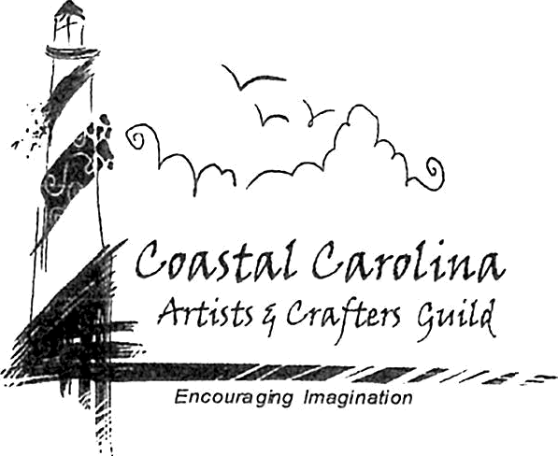Coastal Carolina Artists & Crafters Guild

PO Box 1044

Jacksonville NC 28341

Leave a message at 910-938-7077

[ccacguild@yahoo.com](mailto:ccacguild@yahoo.com)

CCACguild.org

**ABOUT US**

***Our purpose is to educate artisans to* grow *their business, create awareness in the community of local* *artists, make charitable distributions to community nonprofit organizations, and inspire creativity.***

We partner with the Small Business center at CCCC to offer monthly educational sessions free of charge to everyone: Business Networking for Artists & Crafters. The curriculum is designed for creative-minded individuals so they may start and successfully grow their business.

Our PLARN (plastic yarn) project not only supports the non-profit Community Paramedics with 6-foot woven plastic mats and now pillows, but it also supports the CHEW program with our excess bags so they can send children home with food. We encourage the whole community to join us free of charge.

Our Bras For A Cause supports Southeastern Cancer Care nonprofit. They help folks in our community with any type of cancer. Our Build A Bra crafting sessions have been so much fun. The decorated bras are donated to us, the artist gets recognition through the public voting at events where the bras are on display and every dollar we take in goes to Southeastern Cancer Care.

Another non-profit we support is Back to Nature-Second Chances. We provide all the decorations for a candy land themed photo opportunity - Pet Photos with Santa during our Winterfest Artisan Market. This year we surprised Rita Rendon (senior wildlife rehabilitator and president) with cork animal ornaments for her to sell. The left-over cork animals have been jazzed up with Mardi Gras masks and will join us in New Bern with our decorated bras. We will keep track of fund raising for the two different nonprofits and give them all the funds we raise.

Unnatural Resource Center in Greenville offers an upcycle / recycle fair open to all ages is another organization we support. Free to enter and you get your creation back. You may win a ribbon or trophy. We have been working on starting the fair in the Jacksonville area.

Our organization offers crafting sessions open to everyone free of charge. During our crafting dates (Making PLARN) we provide all the supplies, and the community is welcome to gain the benefits of creating. We work on different craft projects for our area events.

Globally the Art is Moving organization inspires folks from all over the world to participate in Art Break Day on the first Friday in September. This one day is special because people around the world stop and take a break to make art for free and Jacksonville NC is on the map. All the supplies are provided by us.

We also provide art classes to homeschool groups of 20 to 50 students multiple times a year in the location of their choosing.

We participate in area events with Guild member’s items or with our Bras for A Cause fund raiser. You can find us at Mardi Gras in New Bern, the NC Pacific Arts Festival in Jacksonville, the Renaissance Festival in Kinston, Latino Festival, Jacksonville Jamboree, and other local area events. At each of these events we provide free craft station for anyone to enjoy the benefits of creating.

And last but not least, we co-host our premiere event the Winterfest Artisan Market 3 Day event with the Jacksonville City Parks and Recreation Dept., where artisans and non-profits are given the opportunity to sell handcrafted items in an environment that encourages creativity from vendors as well as the public with our, Cookie Contest, Chair Contest and the Upcycle Art Contest. In addition to the photo opportunity in Candyland theme, Pet Photos with Santa.

Non-profits that we are currently supporting include: Carolina Pine Needle Quilters Guild- Jacksonville, Quilters by the

Sea-Wilmington, Back to Nature-Second Chances, Community Paramedics, CHEW Program, Unnatural Resource

Institute, Southeastern Cancer Care, and Art is Moving.

EIN 36-473581 7